Directions on How to Save Digital Packets

through taking picture on an Android (Google) Phone

1. Complete Packet either by Printed Version or by writing answers on notebook paper (make sure answers are labeled correctly)
2. Go to Google Folder and click on Drive
3. Click on the multi-colored plus sign that pops up:
4. 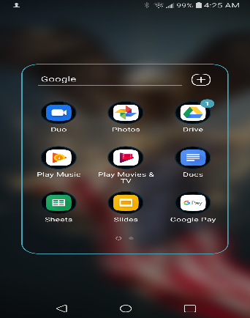
5. 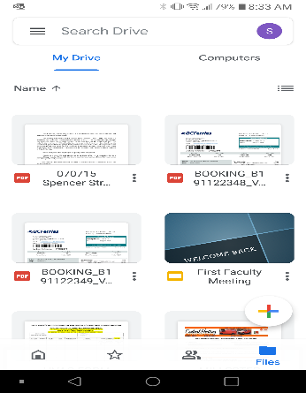
6. Next hit Scan Documents and it will allow you to take multiple pictures and save into one file:
7. 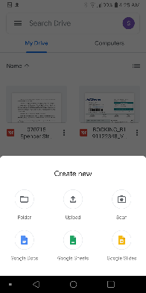
8. Once all photos of the packet have been taken and saved in a file. Send that File from your Google Drive to your teacher Marked clearly with your Name and Title of the packet.